

**London College of Professional Studies**

***Assignment Cover Page***

|  |  |
| --- | --- |
| **Student name** | **Christopher Moyo** |
| **Student ID** | **14034** |
| **Submission date** | **28/08/2023** |
| **Qualification title** | **OTHM Level 6 Diploma in Information and Technology** |
| **Qualification code** | **603/3789/8** |
| **Unit title** | **Advanced Data Analytics** |
| **Unit Reference Number** | **Y/617/3035** |

 I declare that the attached work is entirely my own and that all sources have been acknowledged ☒

Our second predictive analysis was performed on the Food and Beverage Industry. The focus of this analysis was to see how the food and beverage industry performs in relation to the categories of items offered and their sale quantities across various stores. The tools used were Microsoft Visual Studio Code, Jupyter Notebook, and Python programming language. Below is the demonstration.

The used dataset is borrowed from Purvi Kshatriya on GitHub Gist.

1. Adding required libraries and getting the relevant dataset file read into the notebook for analysing and description.

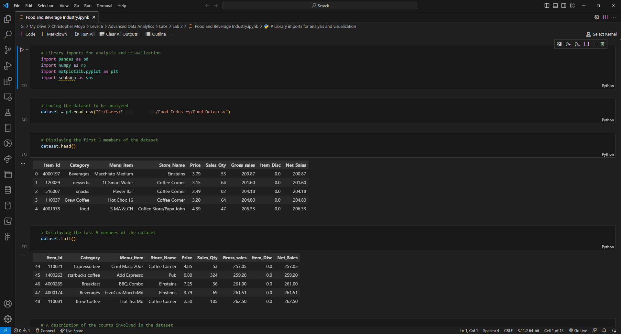

* We begin by importing the relevant libraries we are to use for analysis in line 1, and then prompt the pandas library to read our dataset in line 2.
* Lines 3 and 4 assist us in knowing the first and last 5 members of the dataset.

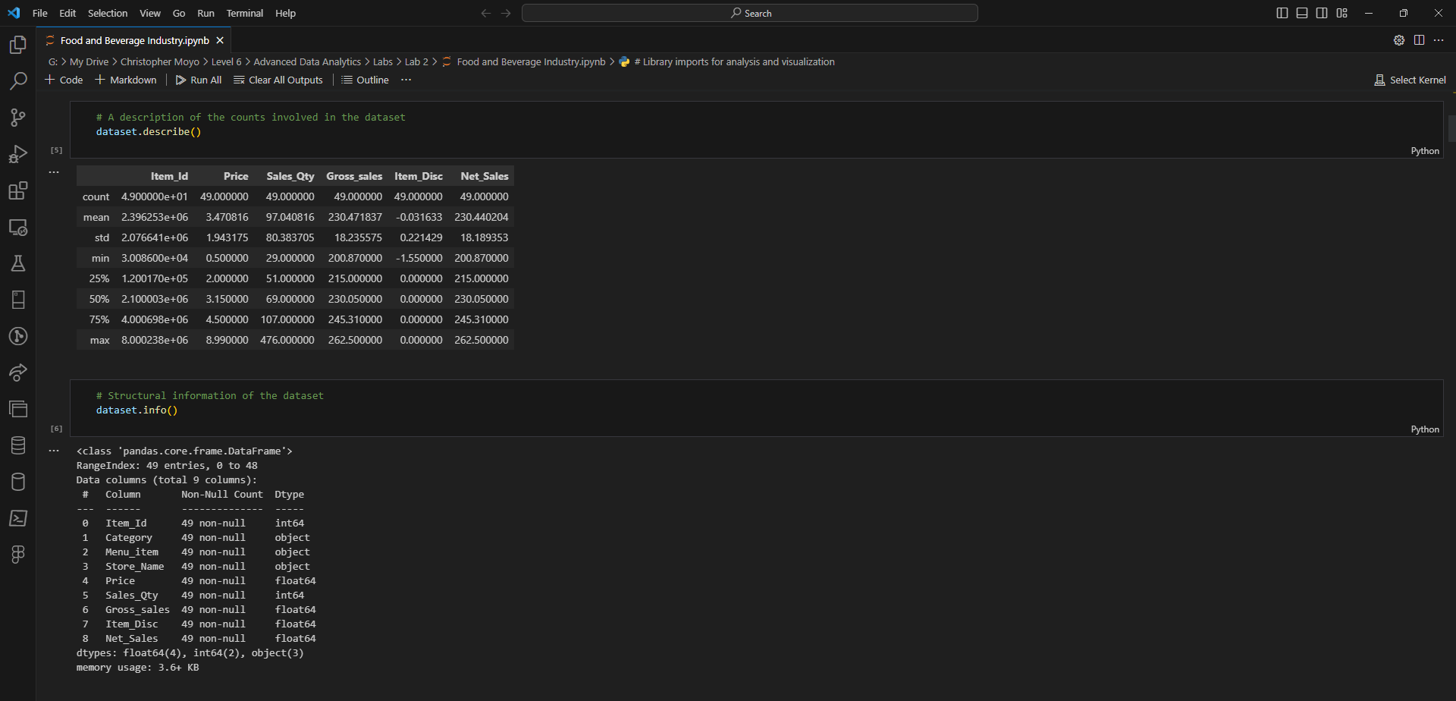

* Cells 5 and 6 are written to show us the description and information of the dataset.

1. **We then show the analysis in form of line charts and bar charts as shown below**.

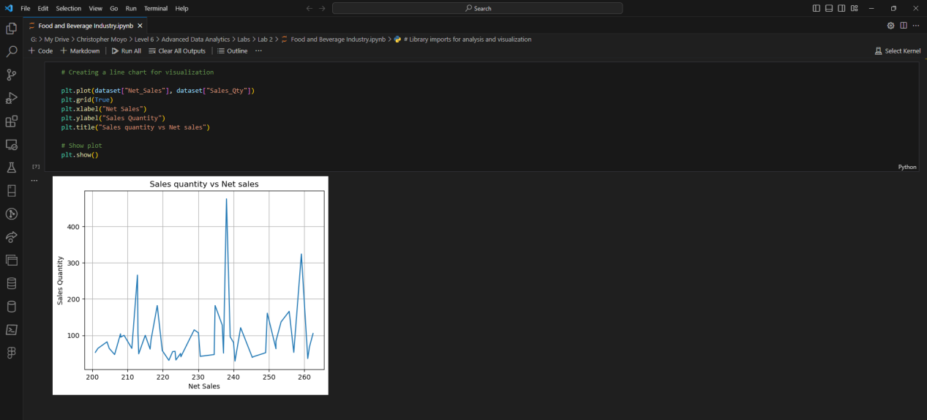

* Cell 7 is used to create a line chart to represent the records of sale quantity vs Net sale of the items across stores.

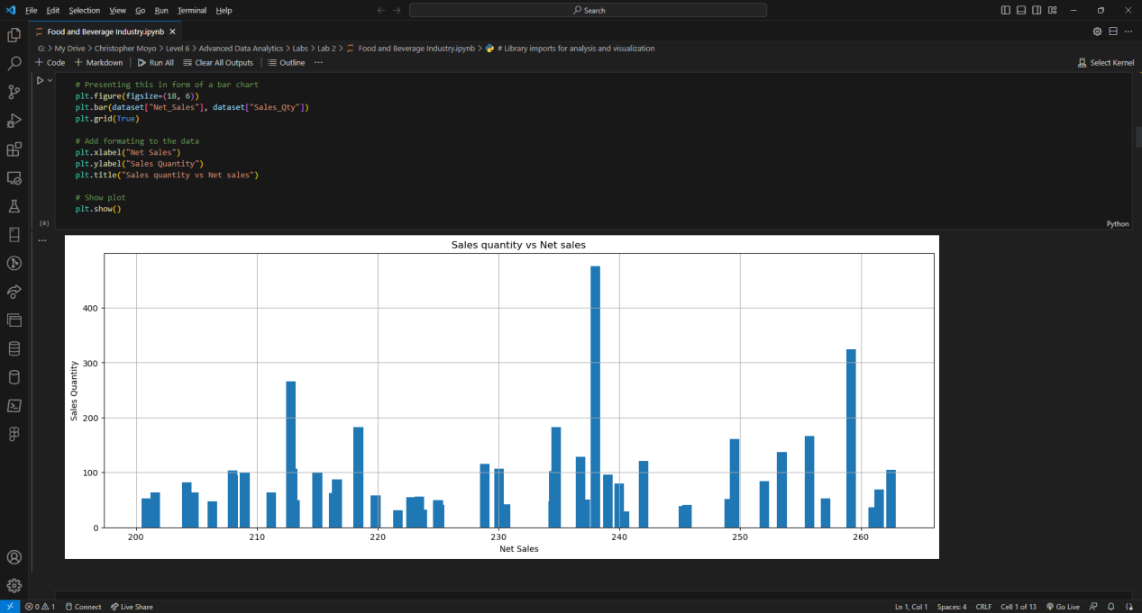

* Cell 8 is written to plot a bar chart of the sales quantity vs Net sales.

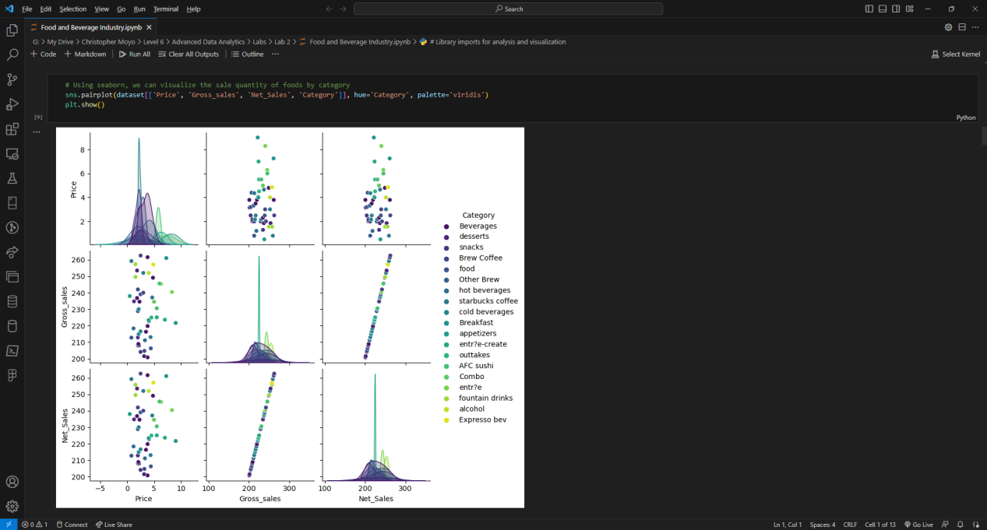

* We then use the seaborn library to visualize the price vs net sale vs gross sales in relation to the category of items in mixed graphs.

1. Extra predictive analysis measures can be done through data grouping and displaying the grouped graphs, as shown below:

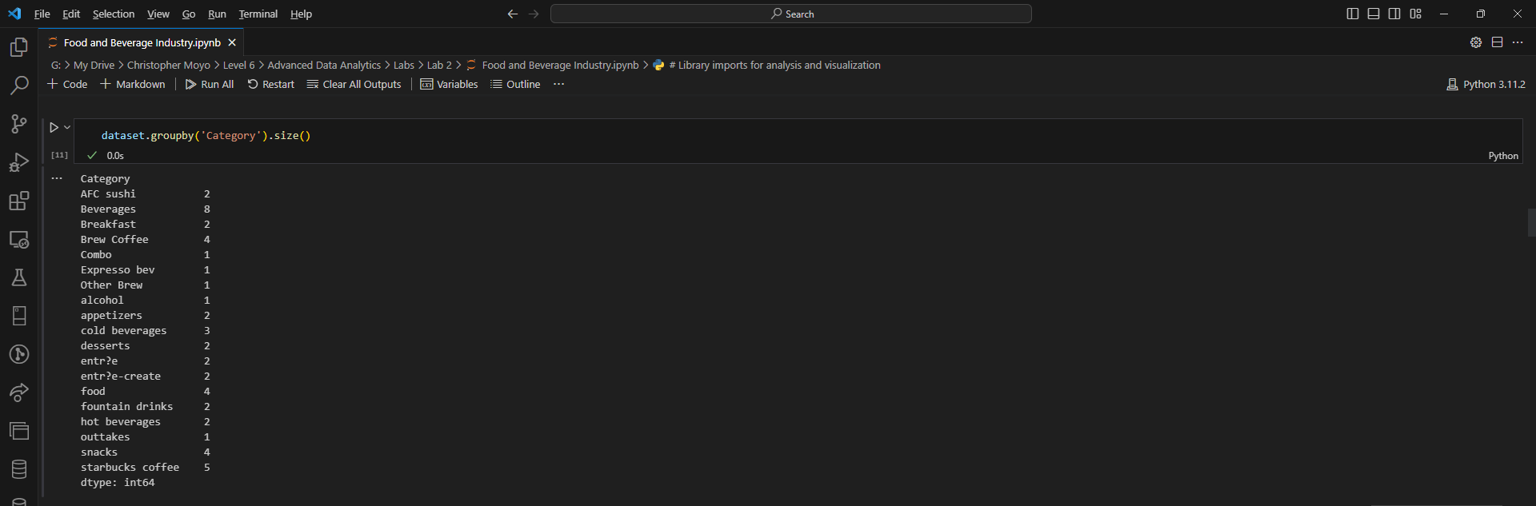

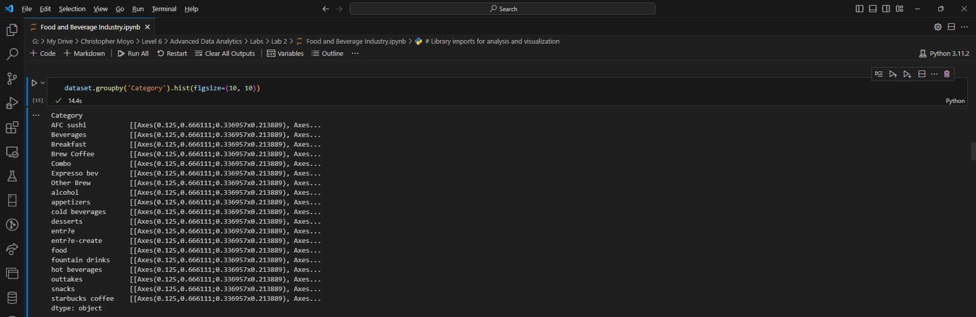

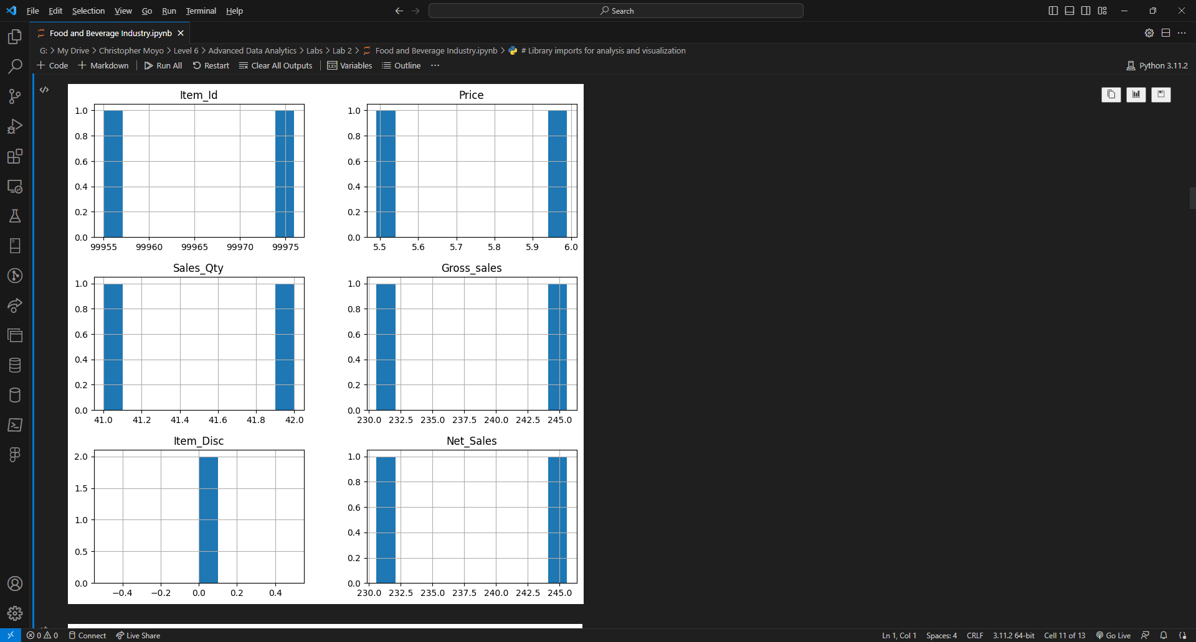

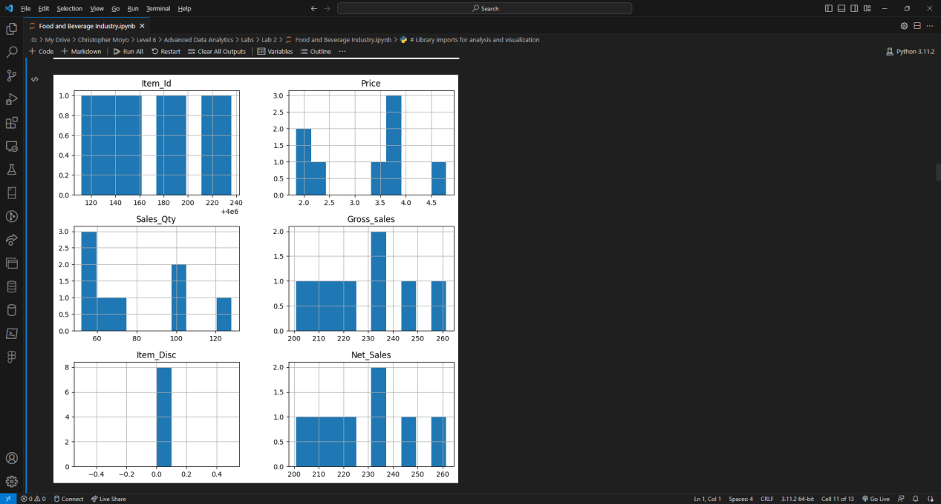

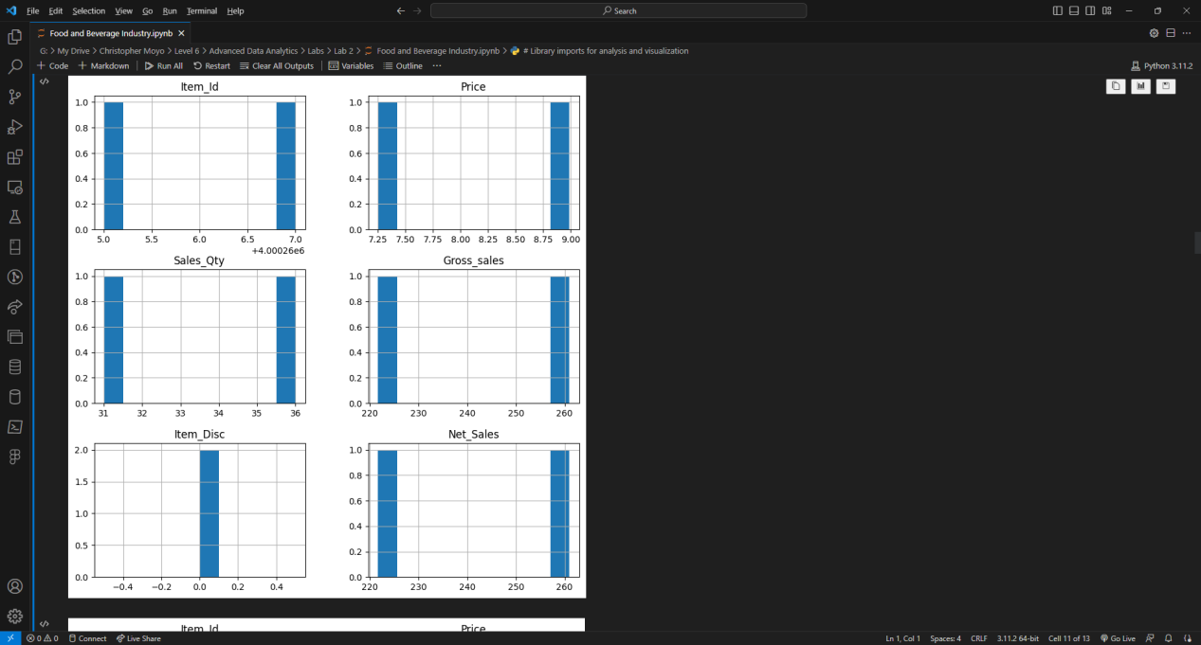

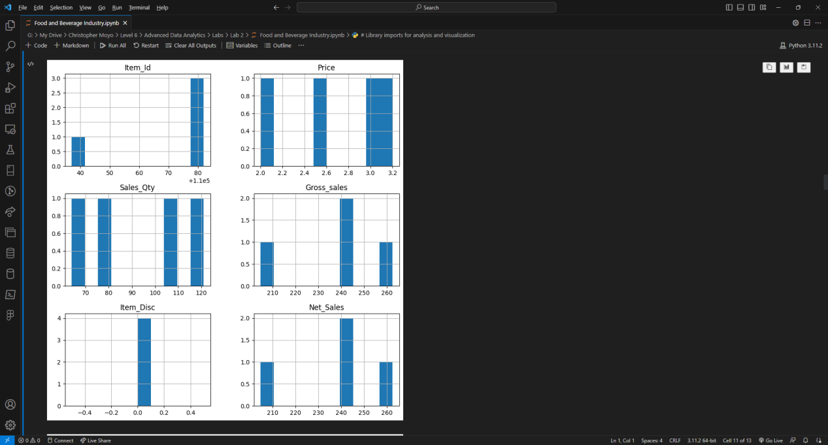

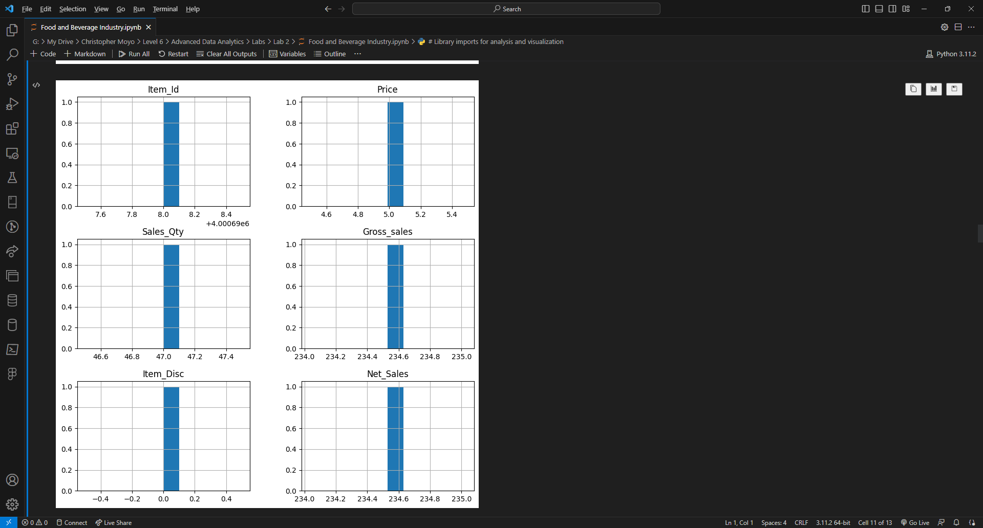

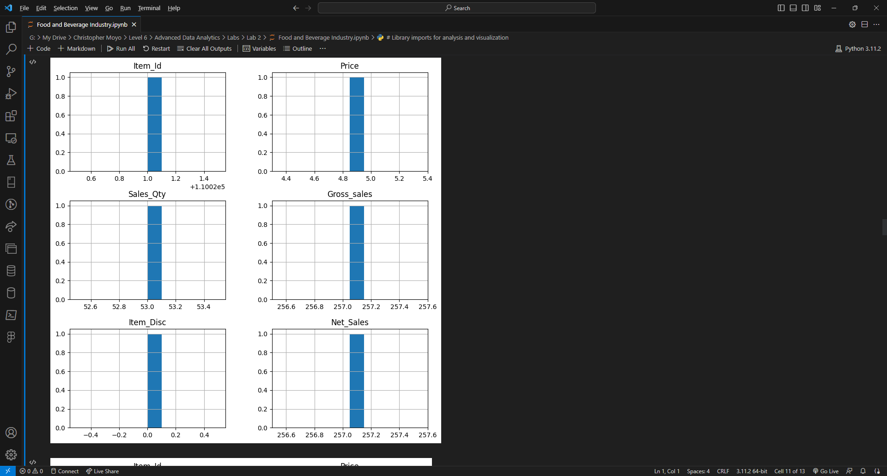

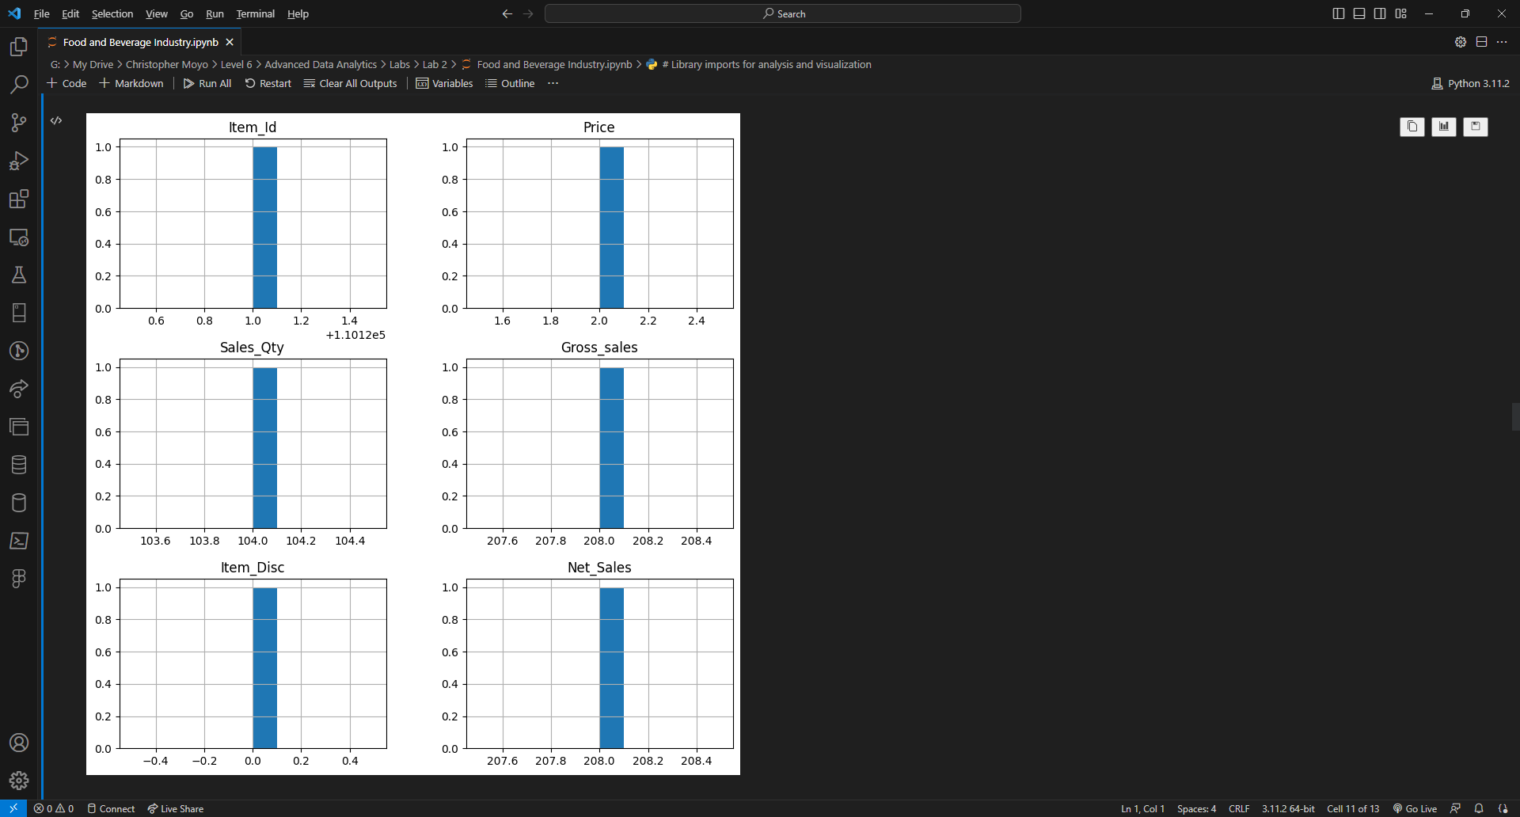

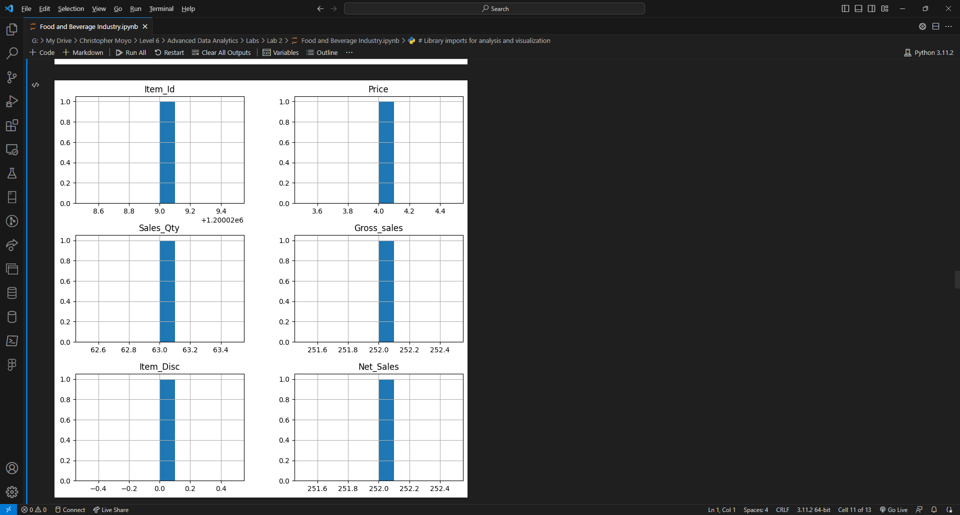

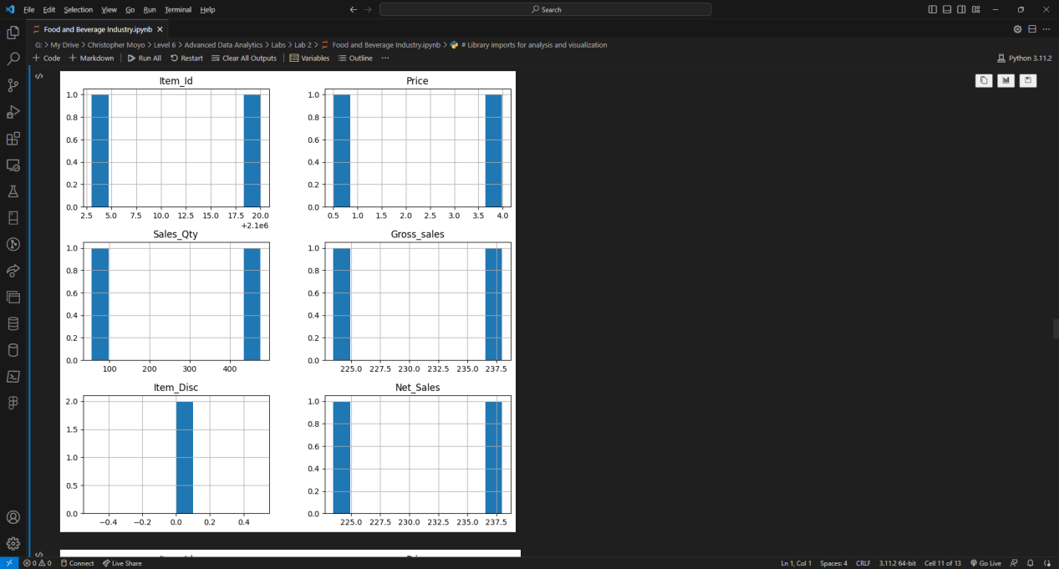

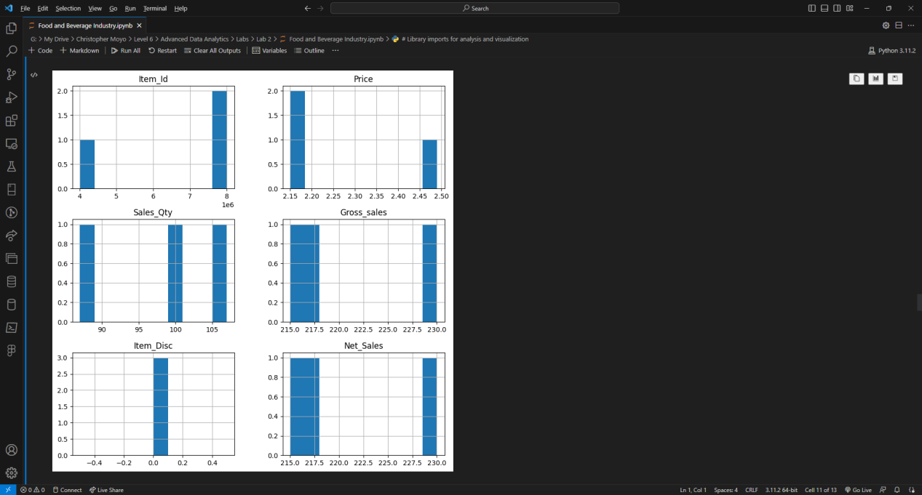

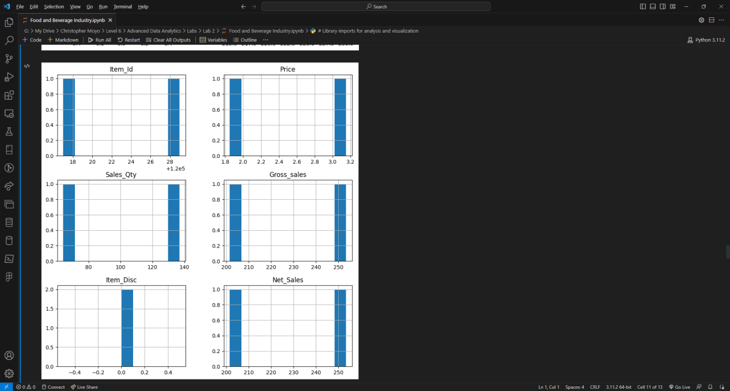

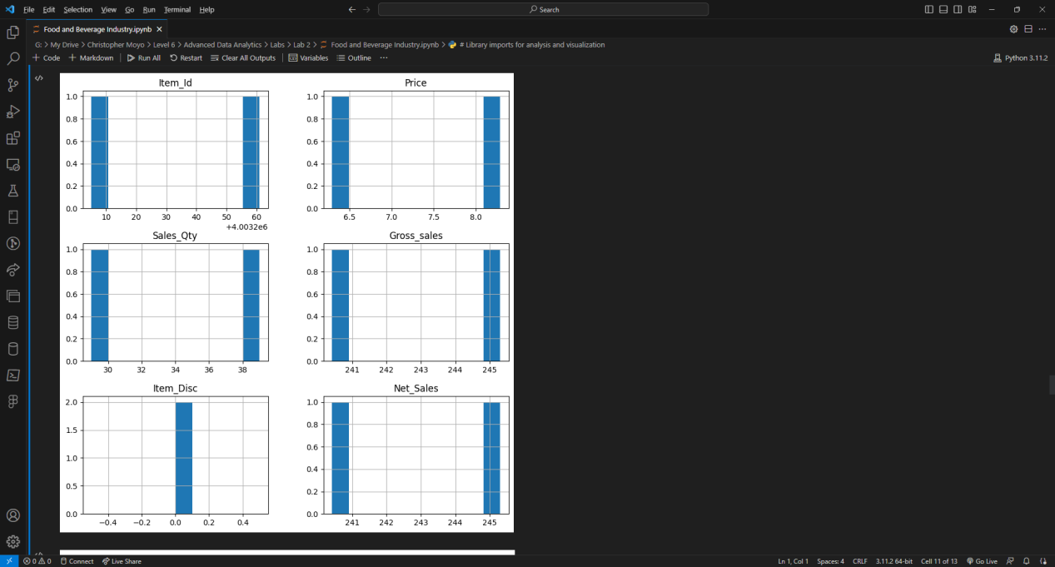

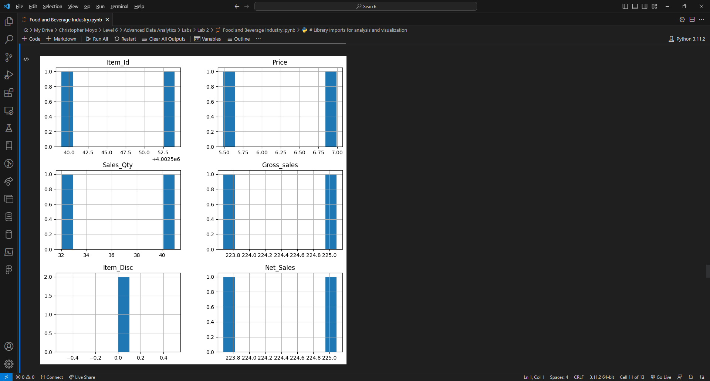

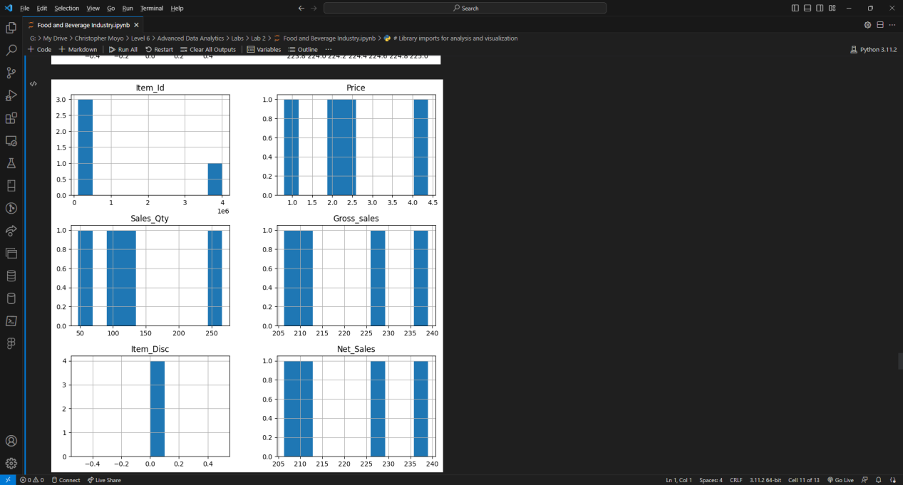

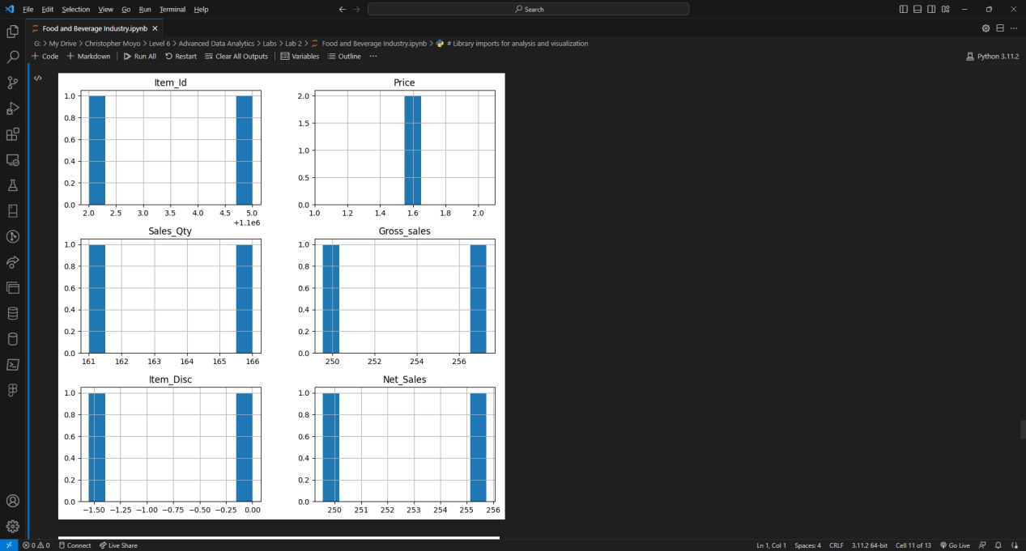

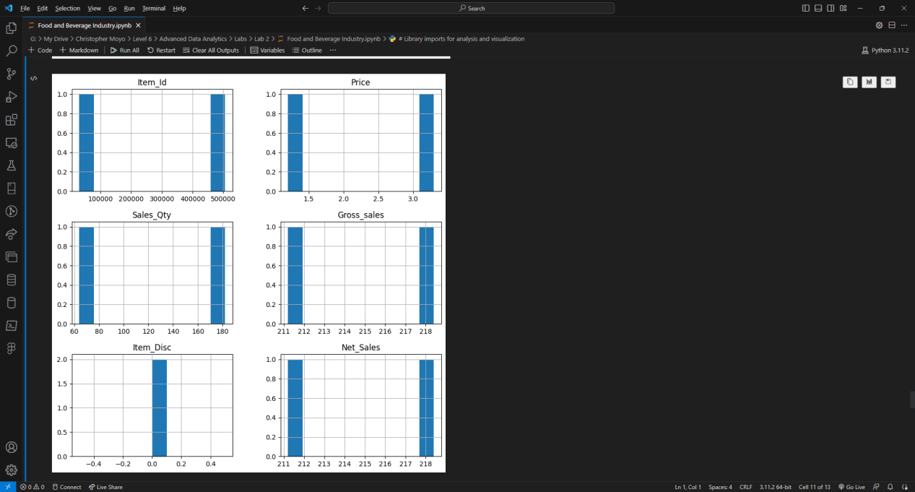

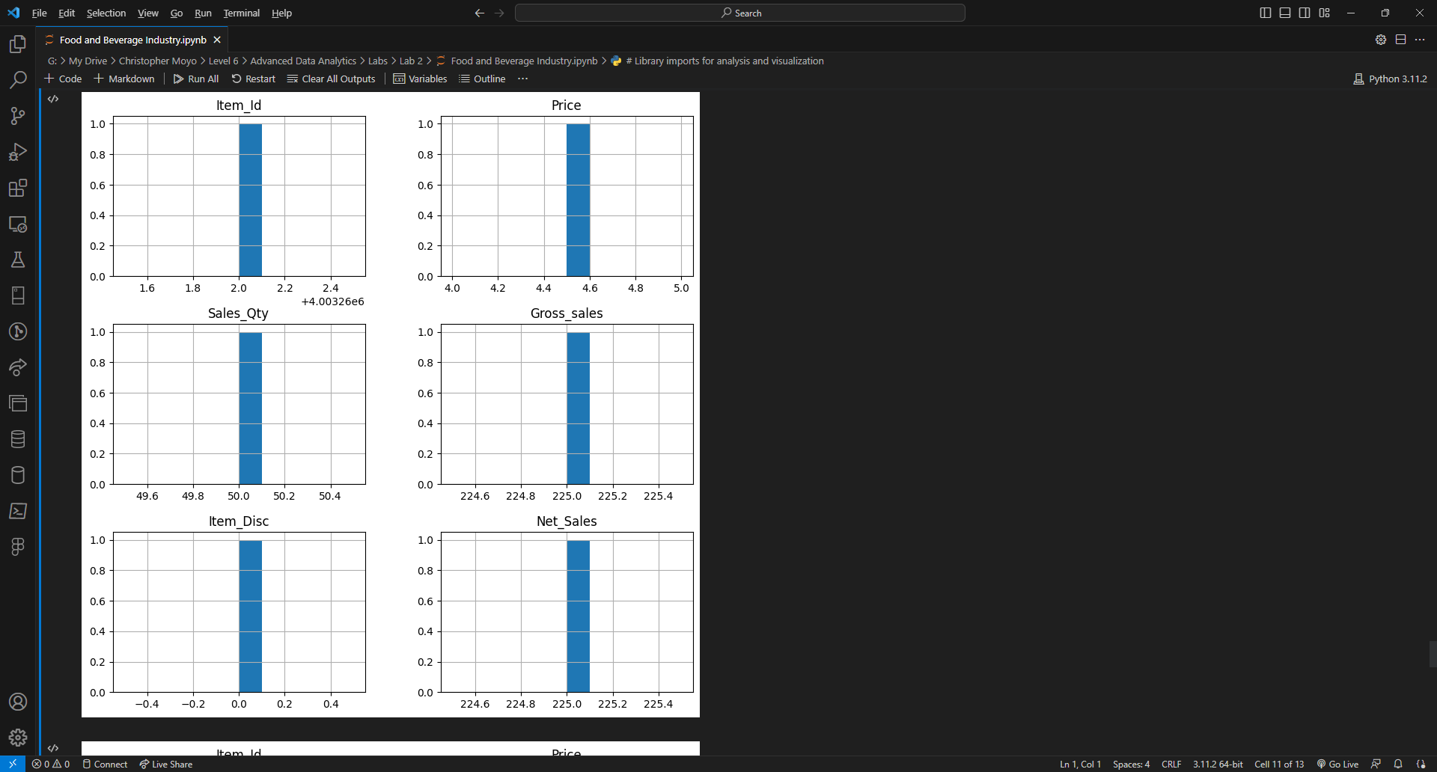

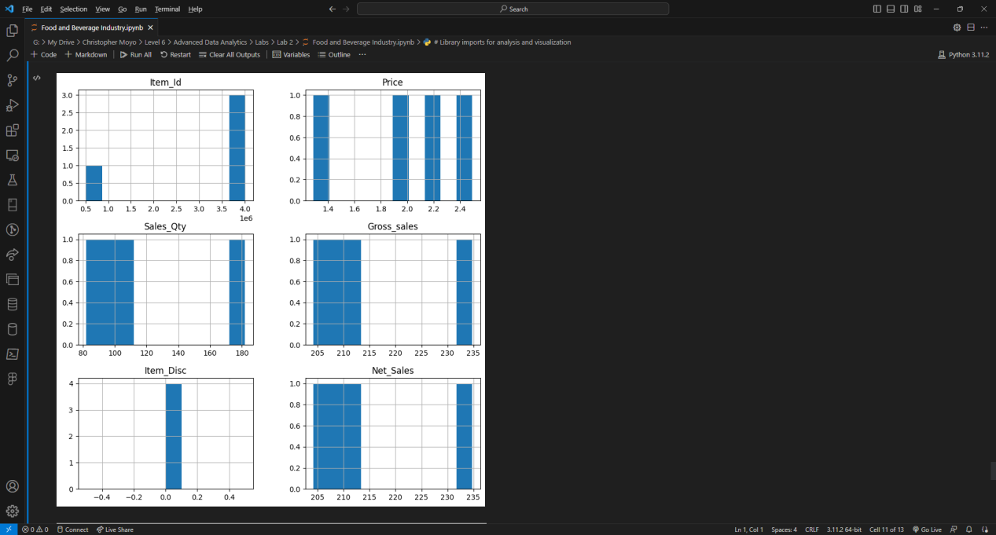

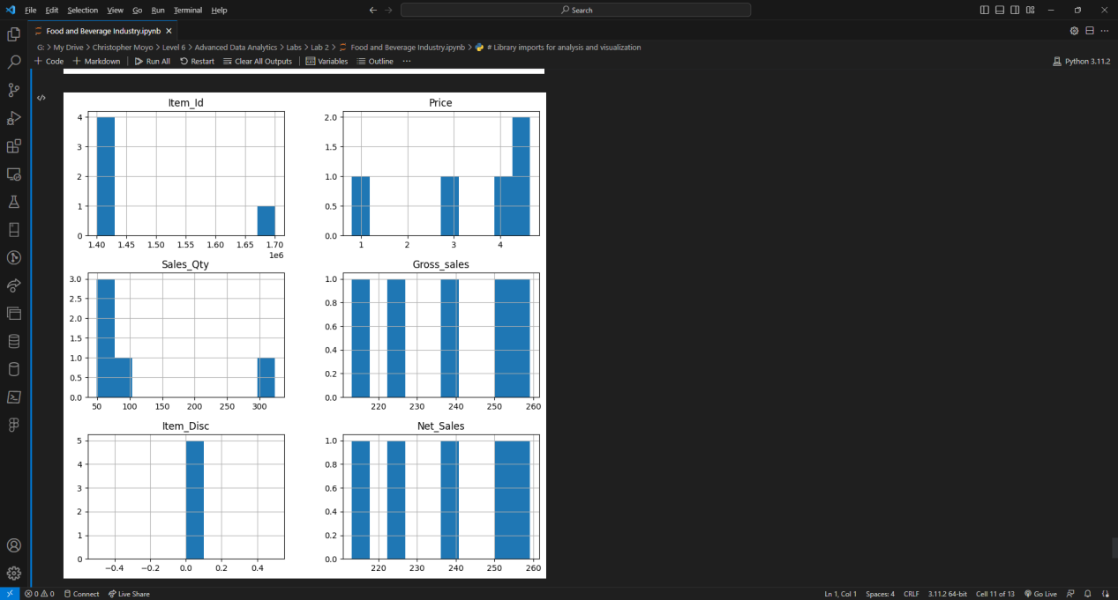

**References**

1. Kshatriya, P. (2015). *Food_Data.csv*. Available at: <https://gist.github.com/PurviKshatriya/7709404cf4fbe492748a.> [Accessed 25 August 2023].